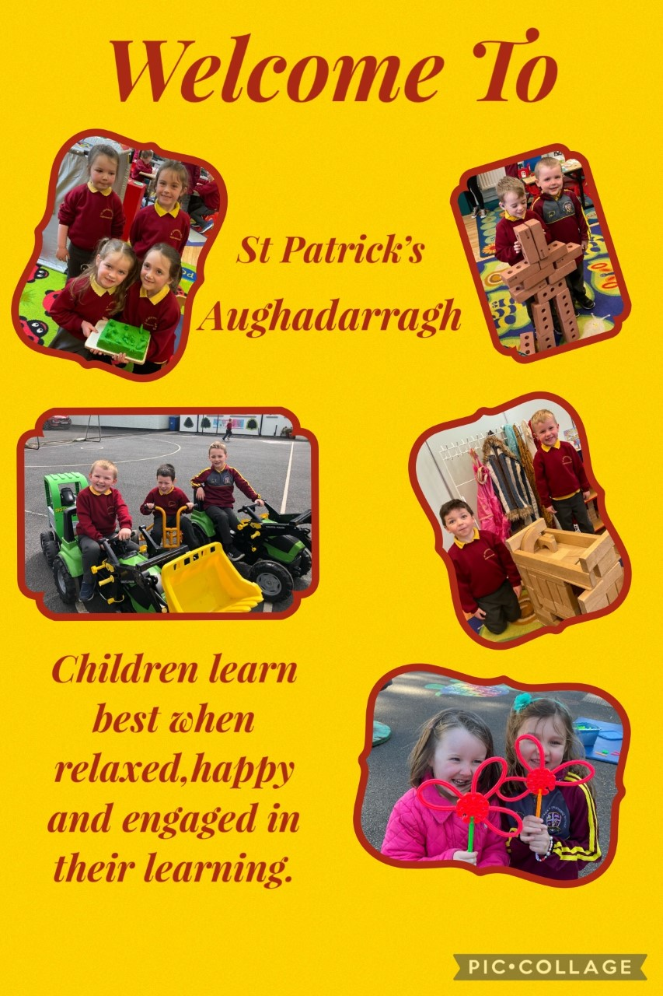

Transition to Primary 1

* Read stories daily to your child, talk to him/her, listen to him/her and try to answer your child’s questions truthfully.



* Encourage your child to engage in discussion about the story/pictures. Retell the story or predict what might happen next.



* Say nursery rhymes with your child. Sing simple songs.
* Count with your child while he/she is playing. Allow your child to sort and count objects, coloured buttons, lego blocks, tins, coins etc… Let your child help you at home, setting the table, packing away groceries and washing dishes. Bring your child shopping with you and let him/her handle and count money.

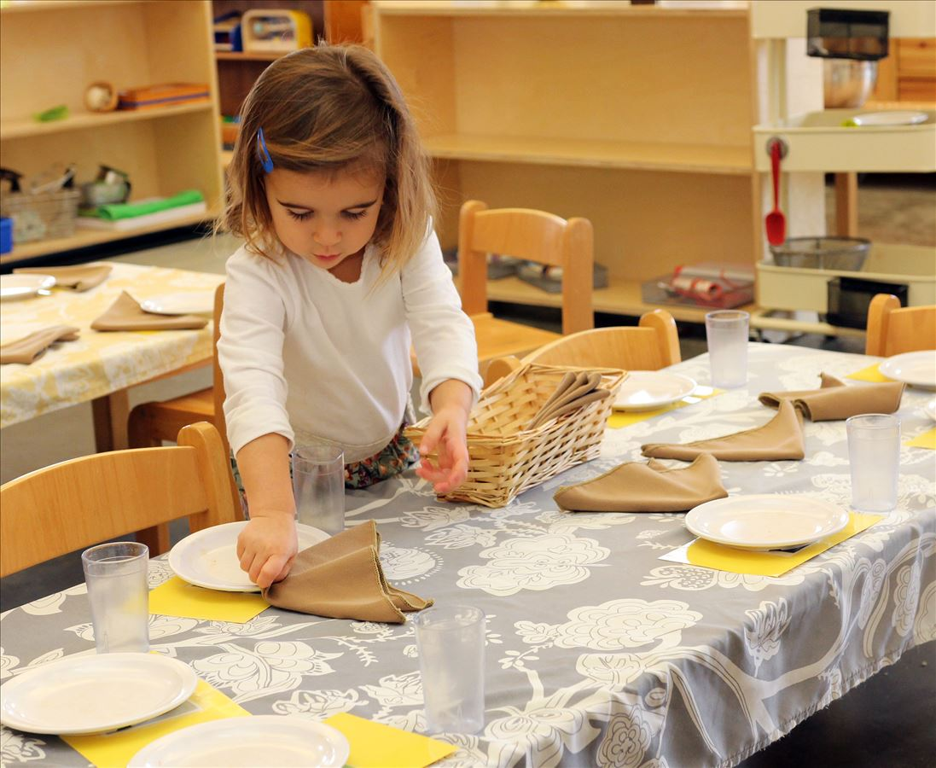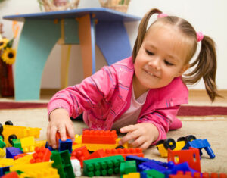

* Talk to your child about the basic colours and ensure they have the common colours to colour with at home. Make sure they also have glue and scissors in order to complete some homework activities.
* Show your child the proper way to use the toilet and to wash their hands afterwards. Show your child how to use a tissue independently.
* Train your child how to dress/undress and put on a coat. Incidentally make sure your child’s coat and bag are clearly marked with his/her name before he/she comes to school.

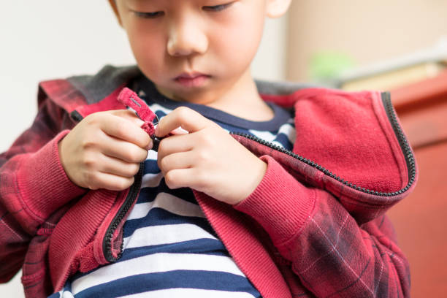

* Ask your child to help tidy up after play. Don’t be tempted to do it all for them. This practice is great training and is really helpful to a busy teacher.
* Limit TV and screen usage. Encourage your child to talk about what they are doing and play with them.
* Allow your child plenty of opportunities to paint/draw/scribble/write. Don’t worry if your child cannot write their own name. If writing his/her own name please use capital letter only for initial letter and ensure correct letter formation. Encourage your child to hold a pencil/crayon/marker properly.

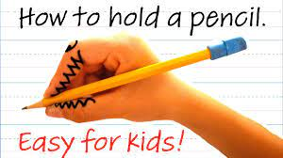

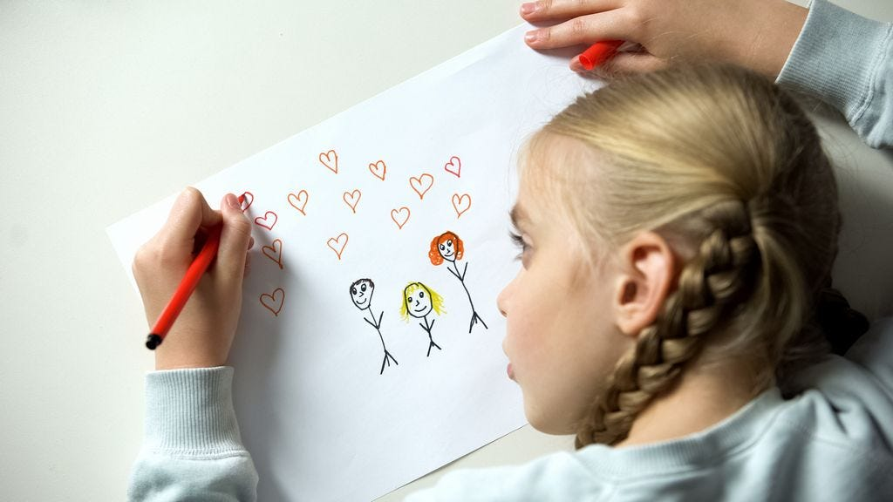

* Encourage your child to mix with others and to share with them.



‘Young children whose parents are actively involved in their early learning make significantly more progress than those who don’t’.

Peers Early Education Partnership

‘

The Curriculum

Primary 1 and 2 is known as the Foundation Stage.

Aims

* To develop young people to reach their full potential.
* To equip them with the necessary skills to become independent and confident contributors to society – preparing them for 21st Century.
* To help them make informed and responsible decisions throughout their lives and be Lifelong Learners.

In St Patrick’s we deliver the Northern Ireland Curriculum which ensures that children are taught at a pace which is developmentally appropriate for them. There is a strong emphasis on play-based learning and personal, social and emotional development.

Areas of the Curriculum

Language and Literacy (Talking and Listening, Reading and writing)

Numeracy

P.E.

ICT,

The Arts (Music, Art and Craft, Drama)

The World Around Us

Personal Development and Mutual Understanding

R.E. (Grow In Love Programme)

We aim to develop motivation, engagement, confidence, tenacity and thinking critically.



Children who read, succeed!!

Your child will begin by telling stories from pictures and by describing settings and characters. They will also join in with repetitive parts of stories and be encouraged to retell parts of a story from memory. The single most helpful thing you can do to help secure your child’s educational success is to read with or to them every day

We use Jolly Phonics when teaching your child to read.

* In Jolly Phonics there is an action which helps the children remember the sound the letter makes. As a sound is taught, it is stuck into a Sound Book which is brought home. If possible go through the sound book every day. The letter names are not taught until the second term. The first group of sounds are s, a, t, i, p and n. These make more 3- letter words than any other six letters. (pan,nip,,sat etc,)
* When blending sounds to make words the initial sound is said slightly louder eg. C-a-t. Some words cannot be sounded out by listening for the sounds in them. These are called Tricky Words and just have to be learnt eg I, saw, he.

reading 5AN01254_

Handwriting

If lower case letters are formed correctly, the pencil should not be lifted – It is a continuous movement for each letter. Watch carefully as your child forms their letters – remember bad habits are hard to change so make sure the direction is right from the start.

Pencil hold

The pencil rests between the thumb and the first finger, the next finger prevents the pencil falling down and the last two fingers are tucked away. The hand rests on the table and it is important that the knuckles point outwards. (Froggy Legs)

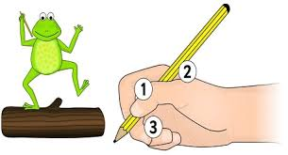

In our independent writing we will not give the children all the words or correct all their spelling. We encourage the children to have a go. It is more important that your child listens for the sounds. At the beginning of Primary 2 a child who is confident with his/her sounds might write the following sentence unaided. -‘mie mumi poot mie book in mie scool bag.’ Accurate spelling comes through reading and following a systematic spelling programme in P2.

When I’m building in the block room,

*Play*

Please don’t say I’m ‘Just Playing.’

For, you see, I’m learning as I play,

About balance, I may be an architect someday.

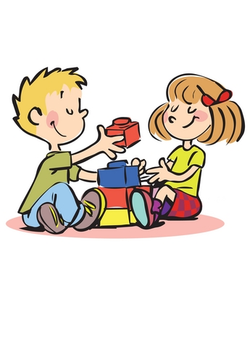When I’m getting all dressed up,

Setting the table, caring for babies,

Don’t get the idea I’m ‘Just Playing.’

I may be a mother or father someday.

When you see me up to my elbows in paint,

Or standing at an easel, or moulding and shaping clay,

Please don’t let me hear you say, ‘He is Just Playing.’

For, you see, I’m learning as I play.

I might be a teacher someday.

When you see me engrossed in a puzzle

Or some ‘playing’ at my school,

Please don’t feel the time is wasted in ‘play,’

For you see, I’m learning as I play.

I’m learning to solve problems and concentrate.

I may be in business some day.

When you see me learning to skip, hop, run and move my body,

Please don’t say I’m ‘Just Playing.’

For, you see, I’m learning as I play.

I’m learning how my body works.

I may be a doctor, nurse or athlete some day.

When you ask me what I’ve done at school today,

And I say, ‘I just played.’

Please don’t misunderstand me.

For, you see, I’m learning as I play.

I’m learning to enjoy and be successful in my work.

I’m preparing for tomorrow.

Today, I am a child and my Work is Play.

Points To Remember

* The settling-in period is very important. If your child is happy then he/she is more likely to make good progress. Please feel free to discuss your child’s progress at any time. Your child will benefit most if there is a close partnership between home and school. In the first week of September we aim to meet each parent individually for a short time to discuss their child. You will be invited to a meeting again in November and you will receive a written report on your child’s progress at the end of June.
* If you or your child has any worries or concerns that may affect their progress please let us know!
* It is important that your child has adequate sleep in order to work to their potential and in order that they are happy at school.
* Please try and help your child at the beginning of the day by having plenty of time to prepare for school so there is a smooth, anxiety-free start to the day. Make preparations for school the night before. Ensure that your child has time to have a breakfast which will sustain them throughout the morning.
* [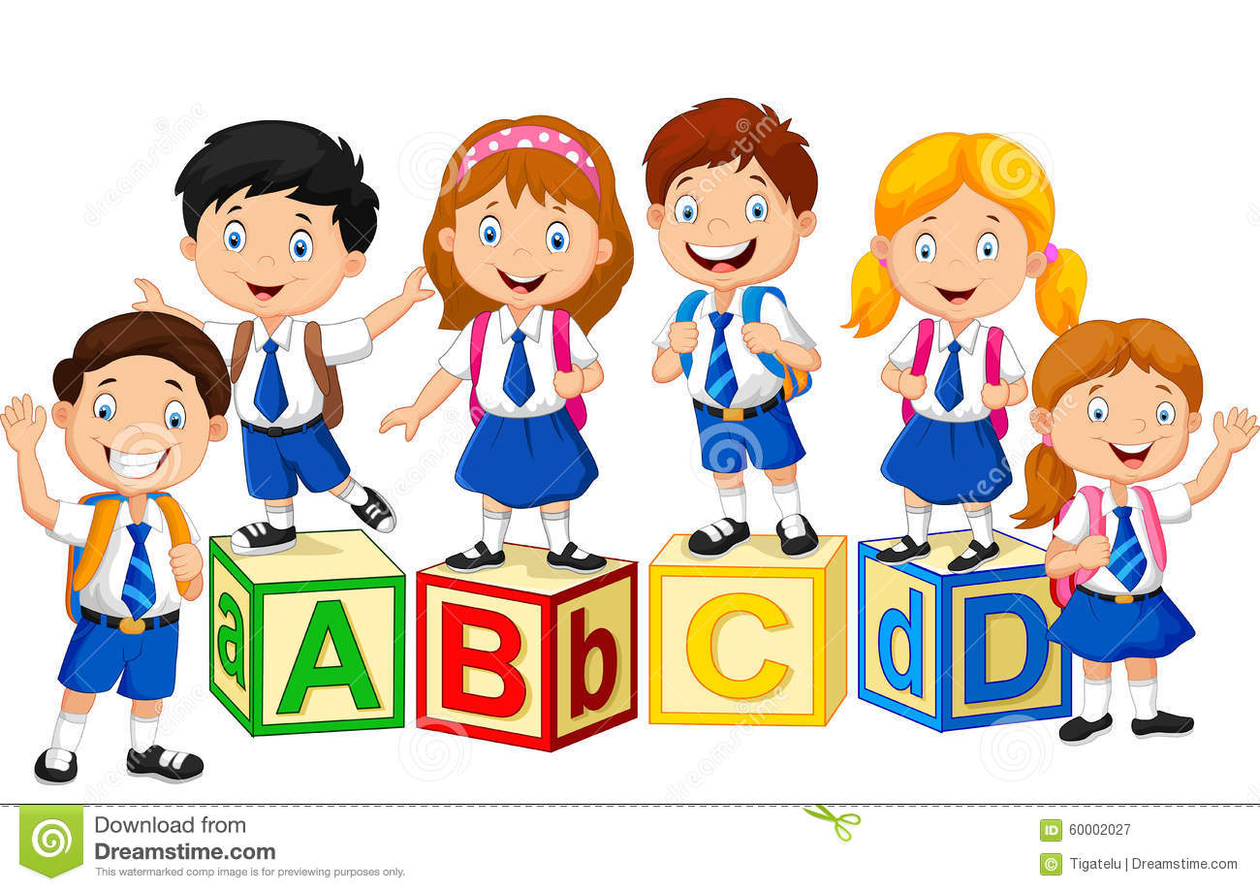](https://www.google.co.uk/url?sa=i&rct=j&q=&esrc=s&source=images&cd=&cad=rja&uact=8&ved=0ahUKEwjChuDNy7jUAhWGIMAKHWb1C2AQjRwIBw&url=https://www.dreamstime.com/stock-illustration-happy-school-kids-alphabet-block-illustration-image60002027&psig=AFQjCNET6GopsZsoHidpqNDjt-GC_1JVHQ&ust=1497366610862113)Encourage your child to put away his/her own books after completing homework. We will provide a folder for all reading books and homework. It is important that you encourage your child to take care of all school resources.
* 10 minutes should be ample to complete homework. (Some may wish to spend a little longer colouring in.) Homework is best tackled straight after school. Your child will normally have homework each week day and will choose a Library Book for the weekend.
* Your child will receive a reading book when he/she is ready. It is vital to encourage your child to read this each night and discuss the story to ensure good progress. Prior to Christmas we will spend a lot of time on pre-reading activities.
* 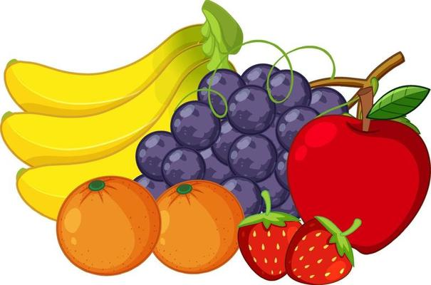Our school promotes healthy eating and encourages healthy breaks such as fruit/veg/yogurt or crackers).
* Each child will be given a water bottle which is filled with fresh water in school each morning.
* The dinners in our school are of a very high quality and are priced ₤2.60 per day. It is best if these are paid on a weekly basis to Marian, our Secretary, or in a sealed envelope. The dinner menu can be viewed on our school website under the Parent Area.

If your child is taking lunch please ensure a healthy lunch and drink.



* Please label your child’s uniform clearly, especially jumpers.
* We use book bags in Primary 1 and 2 instead of school bags. These can be purchased at the school at a cost of £10. This should be cleared out regularly. Your child should not bring pencil cases to school. All pencils, rubbers and crayons will be provided and shared at school.
* If your child is not at school please contact us explaining why he/she is absent, in order that we can complete the Register properly.
* We expect all our pupils to be well behaved, polite and courteous and be capable of working collaboratively together. Much of the first term will be spent teaching the children how to use our environment and how to behave within it.
* Check out our school website. Regularly we will upload photos/videos to show you some of the activities your child has participated in.

www.stpatrickspsaughadarragh.com

